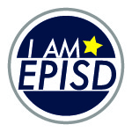
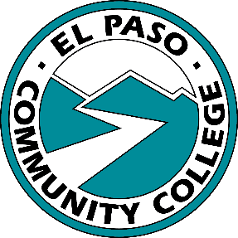
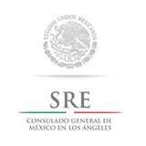
EPISD Fine Arts Department
In collaboration with
El Paso Community College
Present:
“Petcasso: Animals in Art”
Student Art Exhibit K-12

Open invitation to all students enrolled in grades K-12th from El Paso Independent School District
The Art exhibit “Petcasso: Animals in Art” exhibition will focus on The Art Exhibit will focus on the theme of animals. Students may choose any style or appropriate content to express their vision and interpretation of animals among us. Reflective artwork will allow for meaningful dialogue between different age groups and levels on this topic. The Art exhibition will take place at the EPCC Administrative Center located at 9050 Viscount Blvd, El Paso, TX 79925. Opening reception will take place on October 17th from 5:30-7:00 pm. Exhibit will run until October 28th, 2016. Exhibition is open to the public and admission is free.
Guidelines
Size: All entries should not exceed 36” in any direction. This measurement includes dimensions of mat or canvas.
Weight: Maximum weight for any artwork shall not exceed 30 pounds.
Entry Forms: Every item must be identified by an official entry blank that is firmly taped to the back of the work. 3D items should have the entry form attached by a string. Student information, name of school should be written on the back of the artwork in case the entry form is detached.
Inventory List: Each teacher will need to email a typed inventory list of their submissions DUE October 10th, 2016 to Rosa Aguilar at rmaguil1@episd.org Inventory lists need to be accurate as it will be used to generate display labels.
Submissions: All artwork needs to be display ready, work that is not stable or display poor craftsmanship will not be exhibited. All 2D work will need to be mounted or matted (with the exception of canvas or textiles). Individual teachers are responsible for preparing artwork to be displayed. All 3D entries should be placed in a box with proper packing materials, attach entry form to artwork by using a string.

Categories
- Painting: Painting techniques and media; oils, tempera, water based media, watercolor, acrylic, mixed media, encaustic, enamels etc.
- Drawing: Black and white or colored media; chalk, crayons, markers, pencils, charcoal, pen and ink, mixed media etc.
- Design: Art elements on a flat surface; collage, pattern, paper, mosaic etc.
- Printmaking: Graphics; monoprint, serigraphs, silkscreen, collographs, embossed prints, intaglio, lithographs, relief prints.
- Sculpture and Ceramics: 3D arrangement of art elements; assemblage, papier mache, pottery (hand built or wheel thrown), bas relief, ceramics, wire, plaster etc.
- Textiles/Fibers/Jewelry: Body ornaments; soft jewelry, metals, wearable items, rings, pins, necklace, bracelets etc. Weaving, stitchery, macramé rugs, needlepoint, batik, hand cast paper, wall hanging, braiding etc.
- Photography: original photography can be develop by outside source.
- Computer Graphics/ Printed Media and Installation: For all computer entries identification of program is required, for all installation entries required space needs to be disclosed ahead of time for availability.
Entries
5 items per campus will be displayed. Artwork will need to be produced by student with teacher’s approval. Entries must be original and of high quality. If more entries are submitted, please make a note that they are alternates. If space is available, we will include alternate submissions as well.
Deadlines
- Inventory List and delivery of artwork are due October 10th, 2016. Email lists to rmaguil1@episd.org
Exhibition
The Art exhibition will take place at the EPCC Administrative Center located at 9050 Viscount Blvd, El Paso, TX 79925. Opening reception will take place on October 17th from 5:30-7:00 pm. Exhibit will run until October 28th, 2016. Exhibition is open to the public and admission is free.

