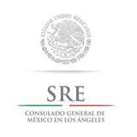
EPISD Fine Arts Department
Invite you to participate in the
K-12 Student Art Exhibit
“Veterans Table: American Stories”

Open invitation to all students enrolled in grades K-12th from El Paso Independent School District The Student Art exhibit “Veteran’s Table: American Stories” will reflect artwork based on American Stories recognizing our heroes, our Veterans throughout time. The K-12 art exhibit will allow for meaningful dialogue between different age groups and levels on this topic. The Art exhibition will take place at the Hal Marcus Gallery located at 1308 N Oregon St. El Paso TX 79902. Opening reception will take place Nov 1, 2018 from 5:00-7:00 pm. Art exhibit is free and open to the public.
The Student Art Exhibit will recognize the tradition of the Veteran’s Table as a tribute to our men and women who served in America’s Armed Forces. For those of you who are not familiar with the Veteran’s Table, please see information below:
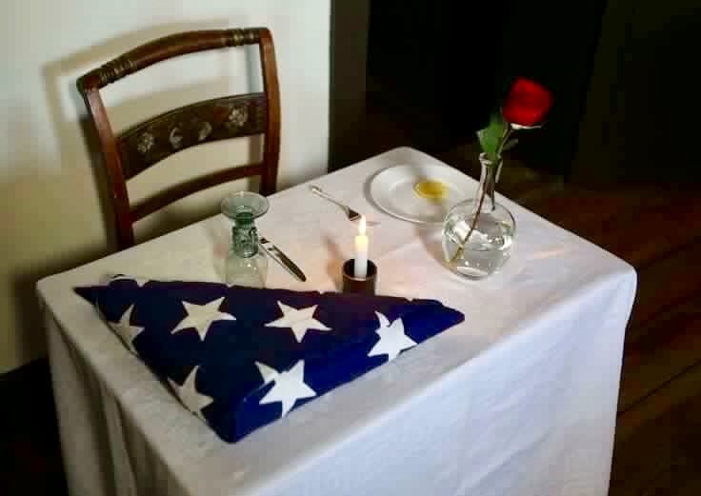

- Veterans Table: set for one, is small, symbolizing the frailty of one isolated prisoner. The place setting reminiscent of the ones who died during service or missing during armed conflict.^{[9]}
- Tablecloth is white, symbolic of the purity of their intentions to respond to their country’s call to arms.^{[11]}
- Single red rose in the vase, signifies the blood that many have shed in sacrifice to ensure the freedom of our beloved United States of America. This rose also reminds us of the family and friends of our missing loved ones who keep the faith, while awaiting their return.^{[12]}
- The red ribbon (yellow ribbon for Air Force ceremonies) represents the love of our country, which inspired them to answer the nation’s call.^{[13]}
- Slice of lemon on the bread plate: represents the bitter fate of the missing.^{[14]}
- Salt sprinkled on the bread plate: symbolic of the countless fallen tears of families as they wait.^{[14]}
- Inverted glass: represents the fact that the missing and fallen cannot partake.
- Lit candle: reminiscent of the light of hope which lives in our hearts to illuminate their way home, away from their captors, to the open arms of a grateful nation.
- Empty chair: the missing and fallen aren't present.^{[16]}

G u i d e l i n e s
Entries
Hal Marcus Gallery has a small exhibit space to display student artwork. Therefore, all of the entries will be no more than 11 inches in size. All entries will be done in a bisque plate provided to you by the Fine Arts Office. Request for Bisque plates will be on a first come first serve basis (5 plates per teacher to start). Bisque plates can be manipulated with any medium (acrylic, oil paint, impasto, monoprint or fired in a kiln). Artwork will need to be produced by student with teacher’s approval. Entries must be original and of high quality. If more entries are submitted, please make a note that they are alternates. If space is available, we will include alternate submissions as well. All Bisque plate request will be available for pick up at the Fine Arts Office for students to create their artwork. Plate hangers will be provided by our Fine Arts Office.

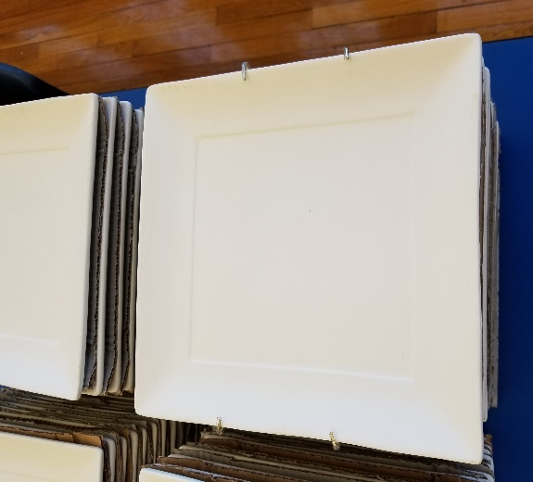

The symbolism of the plates will correlate with the focus of the Veteran’s Table through the stories told by our art students through their artwork.

Deadlines
Inventory List and delivery of artwork are due to Fine Arts on October 25, 2018. Email lists to rmaguil1@episd.org All artwork needs to be turned in to the Fine Arts Office by October 25th, 2018 in order to be considered.

Exhibition
The Art exhibition will take place at the Hal Marcus Gallery located at 1308 N Oregon St. El Paso TX 79902. Opening reception will take place Nov 1, 2018 from 5:00-7:00 pm. Art exhibit is free and open to the public.
Size
All entries should not exceed 11” in any direction. All entries will be done in a bisque plate provided to you by the Fine Arts Office. Request for Bisque plates will be on a first come first serve basis. Bisque plates can be manipulated with any medium (acrylic, oil paint, impasto, monoprint or fired in a kiln). Artwork will need to be produced by student with teacher’s approval. Entries must be original and of high quality. If more entries are submitted, please make a note that they are alternates. If space is available, we will include alternate submissions as well. All Bisque plate request will be available for pick up at the Fine Arts Office for students to create their artwork. Plate hangers will be provided by our Fine Arts Office.

Weight
Maximum weight for any artwork shall not exceed 30 pounds.
Parent Permission Forms
Every item must be identified by an official parent permission form that is firmly taped to the back of the work. Student information and name of school should be written on the back of the plate in case the entry form is detached along. Remember to include the signed form showing parent consent. Parent permission forms can be found at http://visualartsepisd.weebly.com/art-show-guidelines-and-forms.html
Inventory List
Each teacher will need to email a typed inventory list of their submissions DUE Oct 25, 2018 to Rosa Aguilar at rmaguil1@episd.org Inventory lists need to be accurate, as it will be used to generate display labels. Please download inventory list by clicking on http://visualartsepisd.weebly.com/art-show-guidelines-and-forms.html

Submissions
All Bisque plates will need to be display ready, work that is not stable or display poor craftsmanship will not be exhibited. Please request mats to our Fine Arts Office if needed, all artwork will need to be ready for exhibit the day it’s due. Plate hangers will be provided by our Fine Arts Office.

